**BIRDS-X Project**

**Dragonfly EM Thermal Vacuum**

**Test Procedure**

Kyushu Institute of Technology

Laboratory of Lean Satellite Enterprises and In-Orbit Experiments (LaSEINE)





|  |  |  |  |
| --- | --- | --- | --- |
| **Date** | **Version Number** | **Writer** | **Annotations** |
| 2023/11/15 | v1.0 | Merisa Kosiyakul | First Draft |
| 2024/08/02 | v1.1 | Merisa Kosiyakul | Add thermocouple location pictures |

**Contents**

1. Introduction 3

1.1. General 3

1.2. Objectives 3

1.3. Scope 3

2. Reference 3

3. Nomenclature 3

3.1. Acronyms 3

3.2. Symbols 4

4. Test Purpose 4

4.1. Overall test purpose 4

4.2. Corresponding requirements from RAS 4

5. Test Description 4

5.1. Test place and time 4

5.1.1. Test date 4

5.1.2. Test place 4

5.2. Test contents 5

5.3. Test article 5

5.4. Test flow, level and conditions 8

6. Test Facility, Set-Up and Equipment 8

6.1. Test Facility 9

6.2. Test Setup 10

6.3. Thermal Cycle Profile 11

6.4. Heater Positions 12

6.5. Thermocouple Positions 19

6.6. Attachment of Thermocouples 19

6.7. Equipment and Measuring Instruments 20

7. Test Schedule 21

8. Detailed Test Procedure 22

9. Test Output 24

9.1. Test report 24

10. Quality Insurance 27

11. Personnel Assignment 27

12. Safety Requirement 28

1. **Introduction**
   1. **General**

The Thermal Vacuum Test (TVT) of the Engineering Model (EM) of the Drathe Dragonfly satellite shall pass qualification requirements under vacuum conditions and temperature extremes that simulate the predicted space environment.

* 1. **Objectives**

The following are the test objectives:

* Check and analyze various satellite point temperatures under extreme hot and cold conditions.
* Check and analyze the satellite's functionality and operation under the defined temperature range (extremely hot, extreme cold, and middle-temperature conditions).
* Check and analyze the operation of thermal monitors under the defined temperature range.
  1. **Scope**

This document is applied to the thermal vacuum test for Dragonfly EM using the small vacuum chamber at the Center for Nanosatellite Testing (CeNT) at Kyutech.

1. **Reference**

|  |  |  |
| --- | --- | --- |
| **Document number** | **Document description** | **Revision level or Release date** |
| ISBN 1-884989-11-X | Spacecraft Thermal Control Handbook | Second Edition, 2002 |

1. **Nomenclature**

**3.1. Acronyms**

|  |  |
| --- | --- |
| ADCS | Attitude Determination and Control System |
| COM-UHF TRX | UHF transceiver board |
| EM | Engineering Model |
| EPS | Electric Power Subsystem |
| GS | Ground Station |
| LN2 | Liquid Nitrogen |
| OBC | Onboard Computer |
| PCB | Printed Circuit Board |
| SP | Solar Panel |
| TC | Thermocouple |
| TVT | Thermal Vacuum Test |

**3.2 Symbols**

|  |  |
| --- | --- |
| °C | Degree Celsius |
| Ω | Ohm (resistance value) |
| W | Watt |
| Pa | Pascal |

1. **Test Purpose**

**4.1. Overall test purpose**

1. Measure temperatures at different satellite points under extreme hot and cold conditions.
2. Check the satellite's functionality and operation under a defined temperature range (extremely hot, extremely cold, and room temperature conditions).
3. Check the operation of thermal monitors under a defined temperature range.

**4.2. Requirements**

**Table 1. Requirements to be satisfied by the test**

|  |  |
| --- | --- |
| **Requirement Number** | **Requirement Description** |
| **N/A** | All of Dragonfly components/parts temperature range shall be within the operating temperature ranges. |
| **DR 1** | Allowable internal temperature range shall be from -15ºC to 55ºC. |
| **DR 2** | Allowable external temperature range shall be from -40ºC to +80ºC. |
| **DR 3** | Temperature of the battery shall be monitored. |
| **DR 4** | Internal boards shall provide temperature data. |
| **DR 5** | The battery shall be kept within temperature range (0ºC to 50ºC). |

1. **Test Description**

**5.1. Test Place and Time**

**5.1.1. Test Date**

The thermal vacuum test is conducted from **November 9 to November 13, 2023** (5 days), and it includes setup preparation, the actual test cycles (with satellite functional test), and setup recovery.

**5.1.2. Test Place**

Center for Nanosatellite Testing

Laboratory of Spacecraft Environment Interaction Engineering

Kyushu Institute of technology

* 1. Sensui, Tobata, Kitakyushu, 804-8550 Fukuoka, Japan

**5.2. Test Contents**

The test shall consist of:

1. Preparation of the satellite, stand, thermocouples (TCs), sheet heaters, connectors, GS setup, and other materials to be used for the test
2. Attachment of TCs and heaters to the satellite and checking the response/resistance
3. Satellite assembly and checking of satellite functionality in normal laboratory setup (in BIRDS room condition)
4. Installation of the satellite, stand, TCs, external heaters, and connectors inside the vacuum chamber and checking connectivity and responses.
5. Checking the satellite functionality inside the vacuum chamber before closing (atmospheric condition)
6. Vacuuming
7. Measurement of temperature of various satellite points in vacuum conditions during the thermal vacuum test (especially at extreme cold conditions and extreme hot conditions)
8. Checking the satellite functionality during the thermal vacuum test (especially at extreme cold conditions and extremely hot conditions)
9. Antenna deployment test at an extremely cold temperature of Cycle 4
10. Thermal balance test at cold and hot temperature
11. Setup recovery and removing the satellite from the vacuum chamber

**5.3. Test Article**

The test article description is shown in **Table *2***.

**Table 2. Test article description**

|  |  |  |
| --- | --- | --- |
| **No.** | **Article name** | **Quantity** |
| **1** | Dragonfly 2U EM | 1 |

The EM 3D model is shown in **Figure *1***.

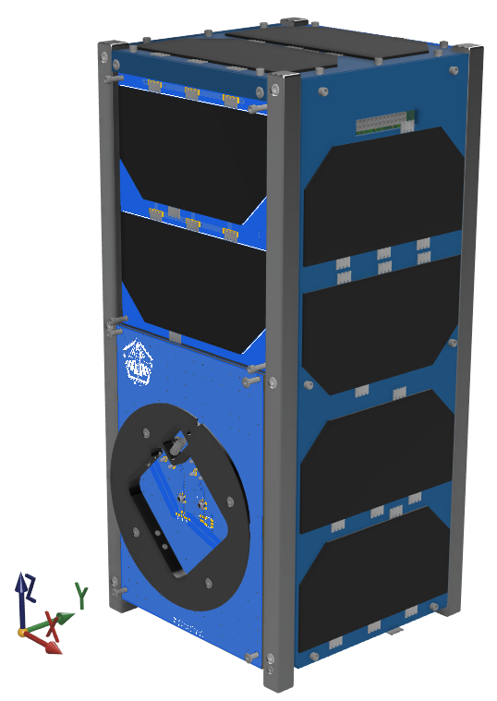

**Figure 1. Dragonfly 2U EM 3D model**

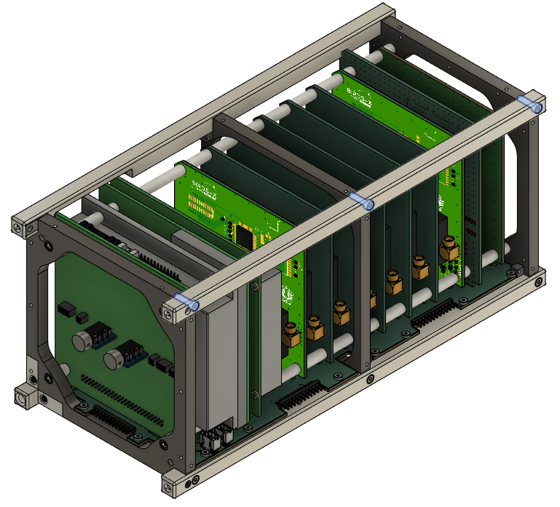

**Figure 2. Dragonfly 2U EM 3D model**

**Table *3*** lists the operating temperature range and survival temperature range of the different subsystems of the Dragonfly satellite. During the test, each subsystem's temperature should be within its operating temperature range.

**Table 3 Subsystem operating temperature range**

|  |  |  |
| --- | --- | --- |
| Subsystem | Operational temperature | Survival temperature |
|  |
| APRS ref1 | -40°C to +85°C | -65 to +125°C |  |
| APRS ref2 | -40°C to +85°C | -65 to +125°C |  |
| Sri Lanka1 | -40°C to +85°C | -65 to +125°C |  |
| Sri Lanka2 | -40°C to +85°C | -65 to +125°C |  |
| Paraguay | -40°C to +85°C | -65 to +125°C |  |
| Canada | -40°C to +85°C | -65 to +125°C |  |
| FAB | -40°C to +85°C | -65 to +125°C |  |
| Solar cells | -40°C to +85°C | -200 °C to +130°C |  |
| Ni-MH battery | +5°C to +25°C | 0 °C to +40°C |  |
| OBC | -40°C to +85°C | -65 to +125°C |  |
| COM | -40°C to +85°C | -65 to +125°C |  |
| New UHF | -40°C to +85°C | -65 to +125°C |  |
| Backplane | -40°C to +85°C | -65 to +125°C |  |
| RAB | -40°C to +85°C | -65 to +125°C |  |

**5.4. Test Flow, Level and Conditions**

Pressure, temperature, and testing duration are described below

* Pressure: the chamber pressure shall be kept below 1 x 10-3 Pa during all conditions of the thermal vacuum test. In this pressure range, heat exchange by molecular flow is negligible.
* Test flow:

**Table 4. Actual test flow**

|  |  |  |  |
| --- | --- | --- | --- |
| **Phase** | | **Duration HH:MM** | **Time HH:MM** |
| Chamber closing, start of vacuuming | | - |  |
| Vacuum reached, room temperature | | ~14 |  |
| **FT0** | | 1:30 |  |
| Cold Ramp1 | Start | 4:00 |  |
| Cold Ramp1 | Stop |
| **FT1** |  | 0:40 |  |
| Hot Ramp 1 | Start | 2:30 |  |
| Hot Ramp 1 | Stop |
| **FT2** |  | 2:00 |  |
| Cold Ramp2 | Start | 3:20 |  |
| Cold Ramp2 | Stop |
| **FT3** |  | 2:00 |  |
| Hot Ramp 2 | Start | 2:15 |  |
| Hot Ramp 2 | Stop |
| **FT4** |  | 1:30 |  |
| Cold Ramp3 | Start | 3:50 |  |
| Cold Ramp3 | Stop |
| **FT5** |  | 1:20 |  |
| Hot Ramp 3 | Start | 1:00 |  |
| Hot Ramp 3 | Stop |
| **FT6** |  | 1:30 |  |
| Cold Ramp 4 | Start | 3:00 |  |
| Cold Ramp 4 | Stop |
| Cold Balance 1 | Start | 13:00 |  |
| Cold Balance 1 | Stop |
| **FT7** |  | 2:00 |  |
| Hot Ramp 4 | Start | 1:00 |  |
| Hot Ramp 4 | Stop |
| Hot Balance 1 | Start | 11:00 |  |
| Hot Balance 1 | Stop |
| **FT8** |  | 1:30 |  |
| Cold Ramp 5 | Start | 2:00 |  |
| Cold Ramp 5 | Stop |
| Cold Balance 2 | Start | 12:30 |  |
| Cold Balance 2 | Stop |
| Cold Ramp 6 | Start | 2:00 |  |
| Cold Ramp 6 | Stop |
| Deployment test |  |  |  |
| Ramp up to room temperature | | 1:00 |  |
| De-vacuuming and recovery | |  |  |

1. **Test Facility, Setup, and Equipment**
   1. **Test Facility**

Specifications of the thermal vacuum chamber are shown in **Table *5***.

**Table 5. Small thermal vacuum chamber specification**

|  |  |  |
| --- | --- | --- |
| **No.** | **Items** | **Specification** |
| 1 | Name | Vacuum thermal shock test equipment |
| 2 | Manufacturer | ULVAC KYUSHU CORPORATION |
| 3 | Size | Overall length 100 (each tub 50) x Ф30 |
| 4 | Material | SUS 304 |
| 5 | Ultimate Vacuum | 1.0 x 10-5 Pa ~ 1.0 x 10-3 Pa |
| 6 | Temperature | -150ºC ~ +150ºC |
| 7 | Thermal Input | No rail: shroud (cold), heater jig (hot)  With rail: shroud (cold), IR lamp (hot) |
| 8 | Dimensions | No rail: 200 x 150 x 150  With rail: 100 x 100 x 100 |
| 9 | Characteristics | -Separate into hot and low temperature side  -Simulate exponential thermal input by moving a satellite in the chamber |

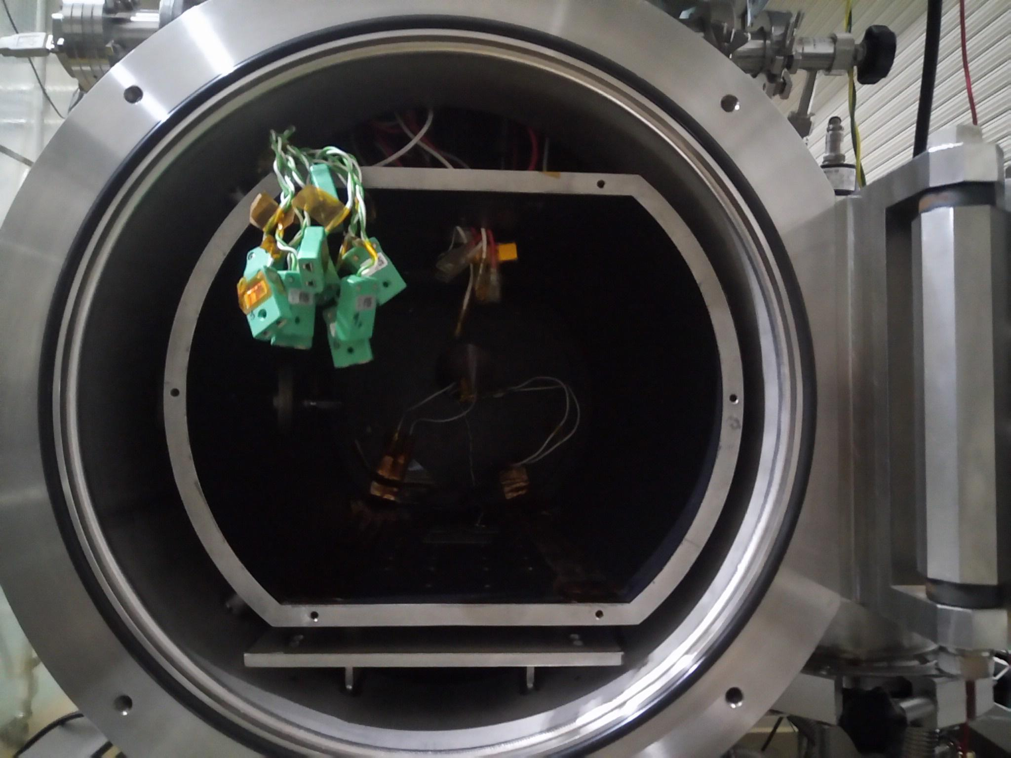

**Figure 3. Small Thermal Vacuum Chamber at CeNT**

* 1. **Test Setup**

The setup diagrams are shown below.

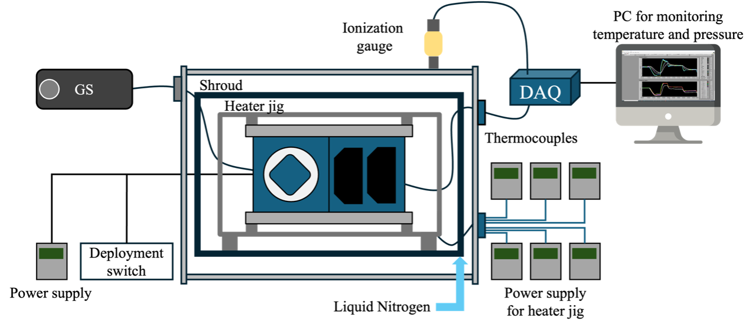

**Figure 4. Overall test setup**

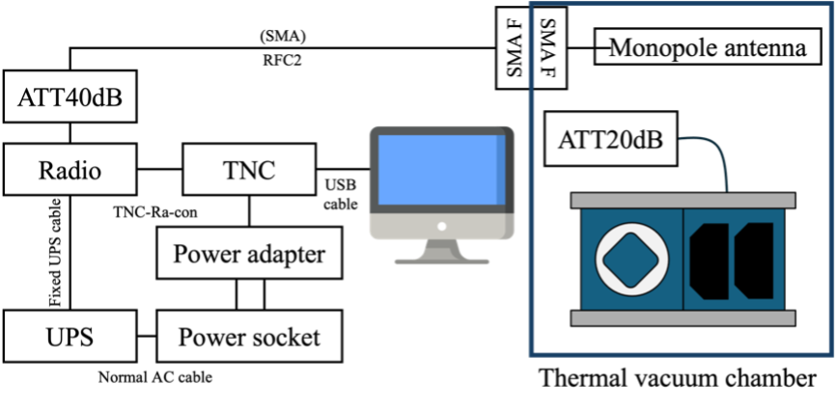

**Figure 5. Connection from COM-UHF transceiver board to GS equipment**

**Figure 6 Placement of the satellite inside the small thermal vacuum chamber**

* 1. **Thermal Cycle Profile**
* The test will be conducted in four cycles (four cold and four hot), as shown in Figure 8. At the extreme cold temperature (-25°c) and at the extreme hot temperature (45°c) of each cycle, functionality tests of subsystems and missions are performed. On the third cycle, the reference temperature is battery temperature at 0°c to conduct a battery discharge test at the cold condition. The extremely hot temperature is 60°c. The thermal balance tests are performed on the fourth cycle.
* There are 21 temperature measurement points total for the Dragonfly satellite, including the six on the external panel’s points.
* The temperature ramp-up (worst cold to worst hot) rate is 45°C/hour, and the temperature ramp-down (worst hot to worst cold) is 30°C/hour.
* The battery temperature will be controlled to reach the lowest possible 0°C in a short time during the last cold soak phase to verify the battery's operation in the worst cold case.

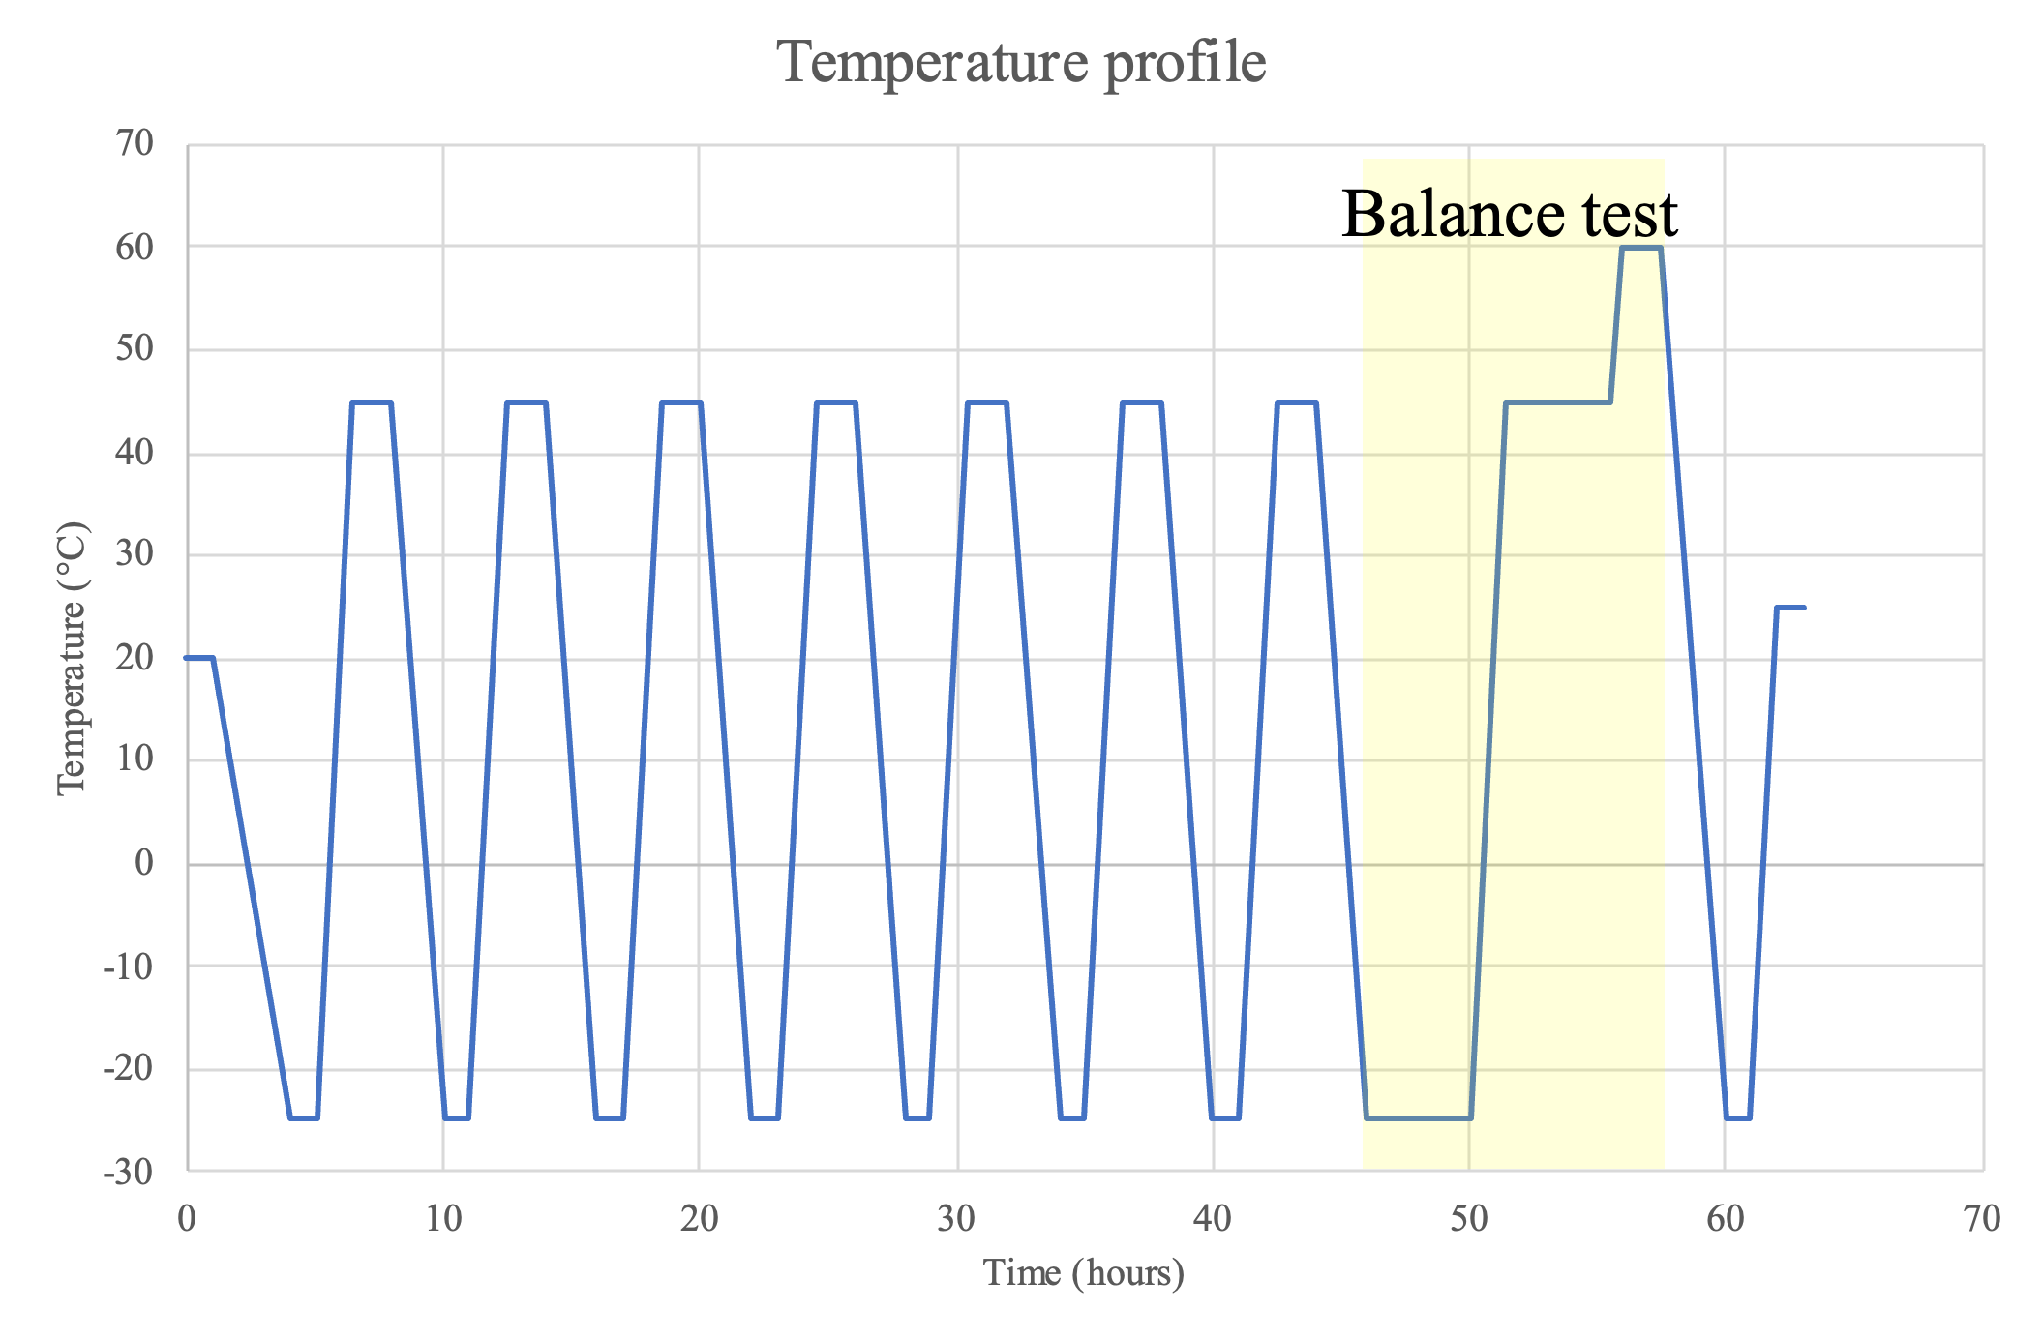

**Figure 7. Test Cycle Profile**

* 1. **Heater Positions**

**Table 6** provides the sheet heater parameters such as position, size, resistance, and maximum power that can be used for the test.

**Table 6.** Heater jig position, resistance, and power

|  |  |  |  |  |
| --- | --- | --- | --- | --- |
| Heater Number | Position | Resistance (Ω) | Maximum Power (W) | Power Supply Number |
| H1 | +X | 7.1 | 100 | 6 |
| H2 | -X | 7.1 | 100 | 5 |
| H3 | +Y | 7.2 | 100 | 3 |
| H4 | -Y | 7.2 | 100 | 4 |
| H5 | +Z | 13.6 | 50 | 2 |
| H6 | -Z | 15.1 | 50 | 1 |

The placement of the sheet heaters is shown in **Figure *8*** below.

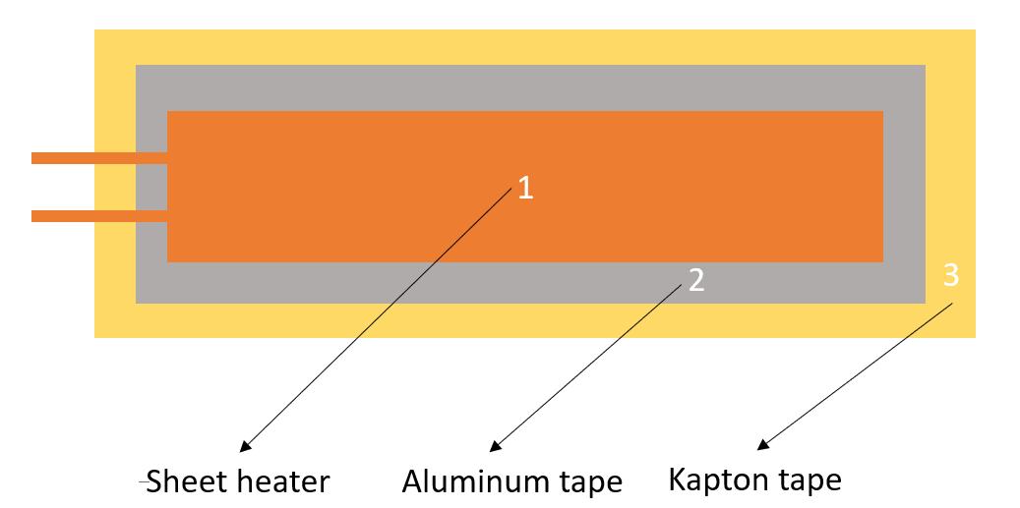

**Figure 8. Heater configuration**

**Thermocouple Positions**

The positions of thermocouples are summarized in **Table *7***.

**Table 7. Positions of Thermocouples (K type)**

|  |  |  |  |  |
| --- | --- | --- | --- | --- |
|  | **Position** | **TC Number** | **TC Number in PC** | **Measurement Point** |
| **1** | Battery box - Top | k19 | 22 | On surface |
| **2** | batter pack (Inside) | k11 | 21 | On surface |
| **3** | FAB | k12 | 1 | Chip |
| **4** | OBC | k21 | 23 | Reset PIC |
| **5** | COM | k10 | 24 | Chip - Right Big Chip |
| **6** | APRS Ref 1 | k18 | 26 | Transceiver |
| **7** | Payload no1 - dummy | k16 | 2 | PCB - Right Top |
| **8** | Payload no2 - Sri Lanka 2 | k08 | 3 | Transceiver - Side |
| **9** | Payload no3 - paraguay | k06 | 4 | Transceiver |
| **10** | Payload no4 - Sri Lanka 1 | k03 | 5 | Transceiver - Side |
| **11** | Payload no5 - Canada | k07 | 6 | Transceiver |
| **12** | APRS Ref 2 | k01 | 9 | Transceiver |
| **13** | New UHF | k04 | 10 | Transceiver |
| **14** | RAB | k02 | 11 | PCB - Right Bottom |
| **15** | Backplane board | k15 | 12 | CPLD |
| **16** | +X panel | k26 | 13 | Middle of plane |
| **17** | -X panel | k28 | 14 | Middle of plane |
| **18** | +Y panel | k27 | 15 | Solar panel - middle |
| **19** | -Y panel | k13 | 25 | Burner circuit |
| **20** | +Z panel | k22 | 16 | Middle of plane |
| **21** | -Z panel | k25 | 17 | PCB |
| **22** | Heater 2Rif | 2Rif | 27 | Heater plate |
| **23** | Heater 2Rib | 2Rib | 28 | Heater plate |
| **24** | Heater 2Lef | 2Lef | 29 | Heater plate |
| **25** | Heater 2Leb | 2Leb | 30 | Heater plate |
| **26** | Heater 2Tof | 2Tof | 31 | Heater plate |
| **27** | Heater 2ToB | 2ToB | 32 | Heater plate |
| **28** | Heater 2Bof | 2Bof | 33 | Heater plate |
| **29** | Heater 2Bob | 2Bob | 34 | Heater plate |
| **30** | Heater 2Ba | 2Ba | 35 | Heater plate |
| **31** | Heater 2Fro | 2Fro | 36 | Heater plate |
| **32** | Shroud Top | - | 18 | Chamber |
| **33** | Shroud Bottom | - | 19 | Chamber |
| **34** | LN2 Control | - | 20 | Chamber |

Figure *9* to Figure *29* show the position of thermocouples that are attached to the satellite:

|  |  |
| --- | --- |
| Internal thermocouple locations | |
| Figure 9 Battery box | A battery in a box  Description automatically generated  Figure 10 Battery cell |
| Figure 11 FAB | Figure 12 OBC |
| Figure 13 COM | Figure 14 APRS Ref1 |
| Figure 15 Payload no1 - dummy | Figure 16 Payload no2 – Sri Lanka 2 |
| Figure 17 Payload no3 - Paraguay | Figure 18 Payload no4 – Sri Lanka 1 |
| Figure 19 Payload no5 - Canada | Figure 20 ARPS Ref2 |
| Figure 21 New UHF | Figure 22 RAB |
| Figure 23 Backplane board |  |
| External thermocouple location | |
| A machine with wires on a table  Description automatically generatedFigure 24 +X panel | A close up of a device  Description automatically generated Figure 25 -X panel |
| A close up of a device  Description automatically generated Figure 26 +Y panel | A machine with wires and wires  Description automatically generated Figure 27 -Y panel |
| A blue rectangular device with black squares  Description automatically generated with medium confidenceFigure 28 +Z panel | A close up of a machine  Description automatically generated Figure 29 -Z panel |

* 1. **Attachment of Thermocouples**

**Figure *30*** shows the steps for attaching the thermocouples to satellite surfaces and components.

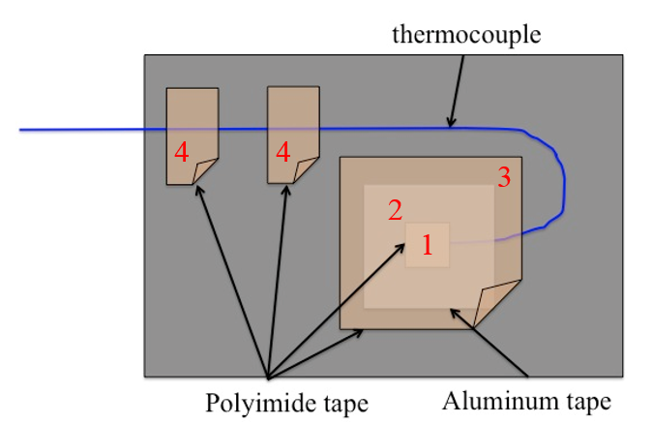

**Figure 30. Attach Thermocouple**

* Step 1: Cover thermocouple tips by a small piece of polyimide tape
* Step 2: Fix the thermocouple terminal using aluminum tape
* Step 3: Cover the aluminum tape by polyimide tape
* Step 4: Fix the thermocouple wire by polyimide tapes
  1. **Placement of the satellite inside the small vacuum chamber**

**Figure 31. Placement of the satellite inside the small vacuum chamber**

* 1. **Equipment and Measuring Instruments**

**Table *8*** shows a list of equipment needed during the thermal vacuum test.

**Table 8. Equipment and measuring instrument details**

|  |  |  |  |  |
| --- | --- | --- | --- | --- |
| **No** | **Equipment** | **Quantity** | **Model** | **Comments** |
| 1 | Thermocouple | 20 | Type-K | -180 to +1300 °C |
| 2 | Sheet Heater | 1 |  |  |
| 3 | 2U Heater Jig | 1 |  |  |
| 4 | Data acquisition PC | 1 | Desktop PC | For chamber control |
| 5 | DAQ-mx | 4 | NI 9213 | 24 bit ADC |
| 6 | Power Supply | 6 |  | 0-320V |
| 7 | Transceiver | 1 | IC-9100 | For functional test |
| 8 | Attenuator | 3 |  | For functional test |
| 9 | Functional Test PC | 2 | N/A | For functional test |
| 10 | Terminal Node Controller | 1 | KPC-9612+ | For functional test |

1. **Test Schedule**

The test schedule is shown in **Table *9*** below.

**Table 9. Test schedule**

|  |  |  |  |  |  |  |  |  |  |  |
| --- | --- | --- | --- | --- | --- | --- | --- | --- | --- | --- |
|  | Day 1  9 Nov | | Day 2  10 Nov | | Day 3  11 Nov | | Day 4  12 Nov | | Day 5  13 Nov | |
| AM | PM | AM | PM | AM | PM | AM | PM | AM | PM |
| Preparation of the satellite, thermocouples (TCs), sheet heaters, connectors, GS setup and other materials to be used for the test |  |  |  |  |  |  |  |  |  |  |
| Attachment of TCs and heaters to the satellite and checking the response/resistance |  |  |  |  |  |  |  |  |  |  |
| Satellite assembly and checking of satellite functionality in normal laboratory setup  Installation of the satellite, TCs, heaters, and connectors inside the vacuum chamber and checking connectivity and responses. |  |  |  |  |  |  |  |  |  |  |
| Checking the satellite functionality inside the vacuum chamber before closing (atmospheric condition) |  |  |  |  |  |  |  |  |  |  |
| Vacuuming |  |  |  |  |  |  |  |  |  |  |
| Inject LN2 |  |  |  |  |  |  |  |  |  |  |
| Thermal Cycle |  |  |  |  |  |  |  |  |  |  |
| Thermal balance |  |  |  |  |  |  |  |  |  |  |
| De-vacuuming, setup recovery and removing the satellite from the vacuum chamber |  |  |  |  |  |  |  |  |  |  |

1. **Detailed Test Procedure**

The detail test procedures shown in ***Table 10*** with tasks need to be done before, during and after the test, the person in charge of each task should check the task once it finished.

|  |
| --- |
| Verification |
| Preparation and checking the satellite and chamber |
| Make vacuum and conduct the thermal test and functional test |
| Stop the test, clean up and check the satellite |

Table 10. Detailed test procedure

|  |  |  |  |
| --- | --- | --- | --- |
| **No.** | **Test** | **Procedure** | **Check** |
| 0 |  | Verify all satellite functionalities and operation (preliminary, in BIRDS Clean Room – SVBL 3F) | **✓** |
| 1 | Preparation of the satellite and chamber | Prepare and check thermocouples | **✓** |
| 2 | Prepare and check heaters | **✓** |
| 3 | Check chamber's heater connections | **✓** |
| 4 | Check chamber's thermocouple connections | **✓** |
| 5 | Check chamber's D-Sub and RF port connections | **✓** |
| 6 | Disassemble structure and center box | **✓** |
| 7 | Attach thermocouples and heaters to Dragonfly | **✓** |
| 8 | Take photos and note the heaters and TCs positions and number | **✓** |
| 9 | Reassemble satellite and check thermocouples and heaters connection | **✓** |
| 10 | Check satellite functionalities | **✓** |
| 11 | Move satellite to the chamber | **✓** |
| 12 | Install the satellite in the chamber | **✓** |
| 13 | Check again all heaters’ and TCs response on the PC | **✓** |
| 14 | Check satellite functionalities | **✓** |
| 15 | Close the chamber | **✓** |
| 16 | Conduct thermal test and functional tests | Make vacuum | **✓** |
| 17 | Inject LN2 | **✓** |
| 18 | Start cold ramp 1 | **✓** |
| 19 | Satellite functional test 1 | **✓** |
| 20 | Start hot ramp 1 | **✓** |
| 21 | Satellite functional test 2 | **✓** |
| 22 | Start cold ramp 2 | **✓** |
| 23 | Satellite functional test 3 | **✓** |
| 24 | Start hot ramp 2 | **✓** |
| 25 | Satellite functional test 4 | **✓** |
| 26 | Start cold ramp 3 | **✓** |
| 27 | Satellite functional test 5 | **✓** |
| 28 | Start hot ramp 3 | **✓** |
| 29 | Satellite functional test 6 | **✓** |
| 30 | Start cold ramp 4 | **✓** |
| 31 | Cold balance test 1 | **✓** |
| 32 | Satellite functional test 7 | **✓** |
| 33 | Start hot ramp 4 | **✓** |
| 34 | Hot balance test 1 | **✓** |
| 35 | Satellite functional test 8 | **✓** |
| 36 | Start cold ramp 5 | **✓** |
| 37 | Cold balance test 2 | **✓** |
| 38 | Start cold ramp 6 | **✓** |
| 39 | Antenna deployment test | **✓** |
| 40 | Start ramp up to room temperature | **✓** |
| 41 | Satellite functional test at room temperature | **✓** |
| 42 | Stop the test | Stop LN2 injection | **✓** |
| 43 | Recovery and check the satellite | Turn on chamber heater to increase chamber temperature | **✓** |
| 44 | Open chamber, move satellite to clean room | **✓** |
| 45 | Satellite functional testing | **✓** |
| 46 | Disassemble satellite | **✓** |
| 47 | Remove TCs and heaters | **✓** |

1. **Test Output**

**9.1. Test report**

* Temperature profile of all measurement points during the test

|  |  |  |  |  |  |
| --- | --- | --- | --- | --- | --- |
| Subsystem | Component | Operational temperature °C | Survival  Temperature °C | Recorded Temperature During the Test  (during stabilized temperature control and excluding error) °C | |
| Lowest | Highest |
| APRS ref1 | Electronics components | -40 to +85 | -65 to +125 | -27.0 | 64.7 |
| APRS ref2 | Electronics components | -40 to +85 | -65 to +125 | -29.7 | 66.4 |
| Sri Lanka1 | Electronics components | -40 to +85 | -65 to +125 | -30.8 | 65.0 |
| Sri Lanka2 | Electronics components | -40 to +85 | -65 to +125 | -29.4 | 63.7 |
| Paraguay | Electronics components | -40 to +85 | -65 to +125 | -30.0 | 66.3 |
| Canada | Electronics components | -40 to +85 | -65 to +125 | -30.8 | 68.2 |
| FAB | Electronics components | -40 to +85 | -65 to +125 | -24.1 | 60.9 |
| EPS | Solar cells (3G 30A) | -150 to +110 | -200 to +130 | -37.8 | 60.4 |
| Ni-MH Battery | +5 to +25 | 0 to +50 | -0.4 | 52.4 |
| OBC | Electronics components | -40 to +85 | -65 to +125 | -20.2 | 64.9 |
| COM | Electronics components | -40 to +85 | -65 to +125 | -24.6 | 64.8 |
| New UHF | Electronics components | -40 to +85 | -65 to +125 | -27.2 | 65.1 |
| Backplane | Electronics components | -40 to +85 | -65 to +125 | -28.5 | 63.0 |
| RAB | Electronics components | -40 to +85 | -65 to +125 | -30.0 | 64.1 |

|  |  |  |
| --- | --- | --- |
| Functional test no. | Time (hours) | Condition |
| FT0 | 1:30 | Vacuumed at 25°C |
| FT1 | 0:40 | Cold condition at -25°C |
| FT2 | 1:55 | Hot condition at 45°C |
| FT3 | 1:55 | Cold condition at -25°C |
| FT4 | 1:30 | Hot condition at 45°C |
| FT5 | 1:20 | **Battery discharge at 0°C** |
| FT6 | 1:30 | **Hot condition at 60°C** |
| FT7 | 1:55 | Cold condition at -25°C |
| FT8 | 1:30 | Hot condition at 45°C |
| Antenna deployment test | 0:10 | +Y and –Y panel at -25°C |

* Functionality tests during the test- Functional test description

|  |  |  |
| --- | --- | --- |
| Function | Description | Check |
| START PIC test | Confirm that MAINPIC and COMPIC work even when RESET PIC is not working | O |
| CW & HK test | Ensure CW is generated and downlinked every 90s | O |
| Confirm that HK can be sent from flash memory to GS | O |
| Ensure CW and HK are understood by decoder | O |
| RESET test | Confirm that "24hour RESET" is working properly | O |
| Verify that the GS command reset can be performed | O |
| APRS test | Verify that each payload is sending a Beacon | O |
| Verify that each payload is operating in Digipeat mode | O |
| Verify that each payload is operating in S&F mode | O |

* Temperature profile of thermal vacuum test

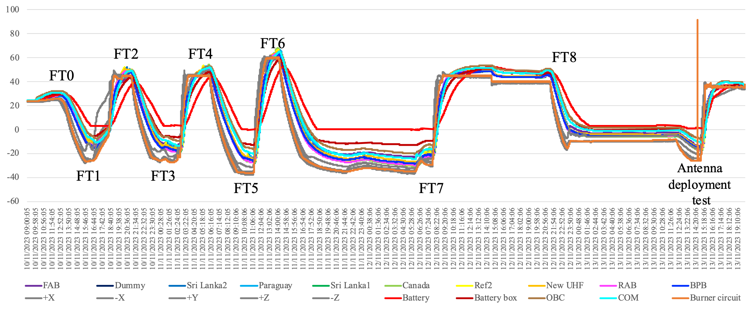

1. **Quality Insurance**

|  |  |
| --- | --- |
| Temperature [oC] | : 20 ± 5 |
| Humidity [%] | : 70 ± 10 |
| Atmosphere | : 10-5 Pa |

1. **Personnel Assignment**

**Table *11*** shows the personnel assignment for the thermal vacuum test.

**Table 11. Personnel Assignment During Setup Preparation**

|  |  |
| --- | --- |
| Task | Responsible Person |
| Ground Station Equipment | Yudai, Javier, Linh |
| Preparation and installation of heaters and thermocouples | Merisa, Yuki, Jorge, Tasuku |
| D-sub Connector Preparation | Miyajima, Nakao |
| Battery Charging Setup | Sara, Linh |
| Antenna preparation | Merisa, Yuki |
| Documentation | Merisa |
| Support | The rest of the team |
| TVT Lead | Masui sensei |
| Team Management | Jorge |

1. **Safety Requirement**

During the test period, in consideration of the safety of work, strictly observe the following matters:

1. During testing, the field officer shall supervise all work and instruct properly to assure the safety of work.
2. Use a crane or a handcart to move any heavy item with anticipated risk.
3. The ceiling crane shall be operated only by licensed personnel. I-bolt / lifting equipment should be inspected each time before operating the crane. No entry to the area under the suspended material is permitted.
4. During testing, keep unnecessary items away from the testing machine.
5. Gloves shall be worn when handling a satellite or sensors.
6. Do not place any item on safety-related motion lines, such as the emergency exit, corridor, fire extinguishers, etc.
7. When a high voltage apparatus is used, turn off the power before inspecting, touching, or modifying, etc.
8. In the case of a natural disaster or a serious accident, take emergency measures and prevent secondary accidents immediately. Then communicate via the following emergency communication links shown below in **Figure *32***.

|  |
| --- |
| **新しい画像.png**  **Figure 32. Emergency procedure flow chart** |

|  |
| --- |
| 1. What to say in Japanese 2. You are the **center, 4th floor**   Kyushu kogyo daigaku, **kogakubu no sogo kenkyu ichi-goto, yonkai de** ________**nin fushosha (= injured)/kasai (= fire)** ga hassei shimasita. Watashi wa ________ (your name) desu.  Kyushu Institute of Technology, General Research Building No. 1, 4th floor. There are ________ people **injured/**There is a **fire**. I am ________ (your name).   1. You are at **SVBL, 1st floor**   Kyushu kogyo daigaku, **kogakubu no sogo kenkyu ni-goto, ichikai de ________nin fushosha (= injured)/kasai (= fire)** ga hassei shimasita. Watashi wa ________ (your name) desu.  Kyushu Institute of Technology, General Research Building No. 2, 1st floor. There are ________ people **injured/**There is a **fire**. I am ________ (your name).   1. You are at **SVBL, 2nd floor**   Kyushu kogyo daigaku, **kogakubu no sogo kenkyu ni-goto, nikai de ________nin fushosha (= injured)/kasai (= fire)** ga hassei shimasita. Watashi wa ________ (your name) desu.  Kyushu Institute of Technology, General Research Building No. 2, 2nd floor. There are ________ people **injured/**There is a **fire**. I am ________ (your name).   1. You are at **SVBL, 3rd floor**   Kyushu kogyo daigaku, **kogakubu no sogo kenkyu ni-goto, sankai de ________nin fushosha (= injured)/kasai (= fire)** ga hassei shimasita. Watashi wa ________ (your name) desu.  Kyushu Institute of Technology, General Research Building No. 2, 3rd floor. There are ________ people **injured/**There is a **fire**. I am ________ (your name). |